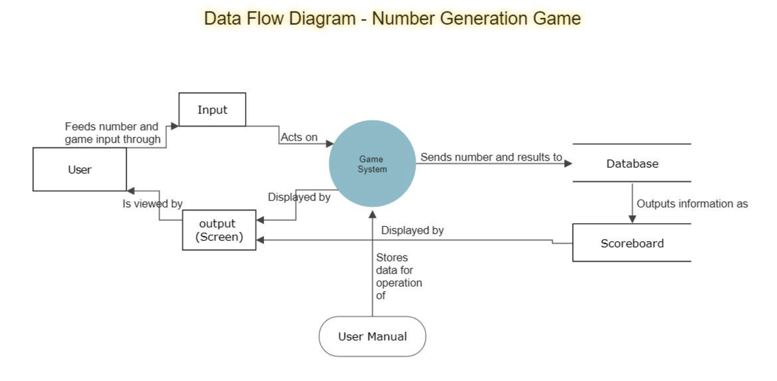
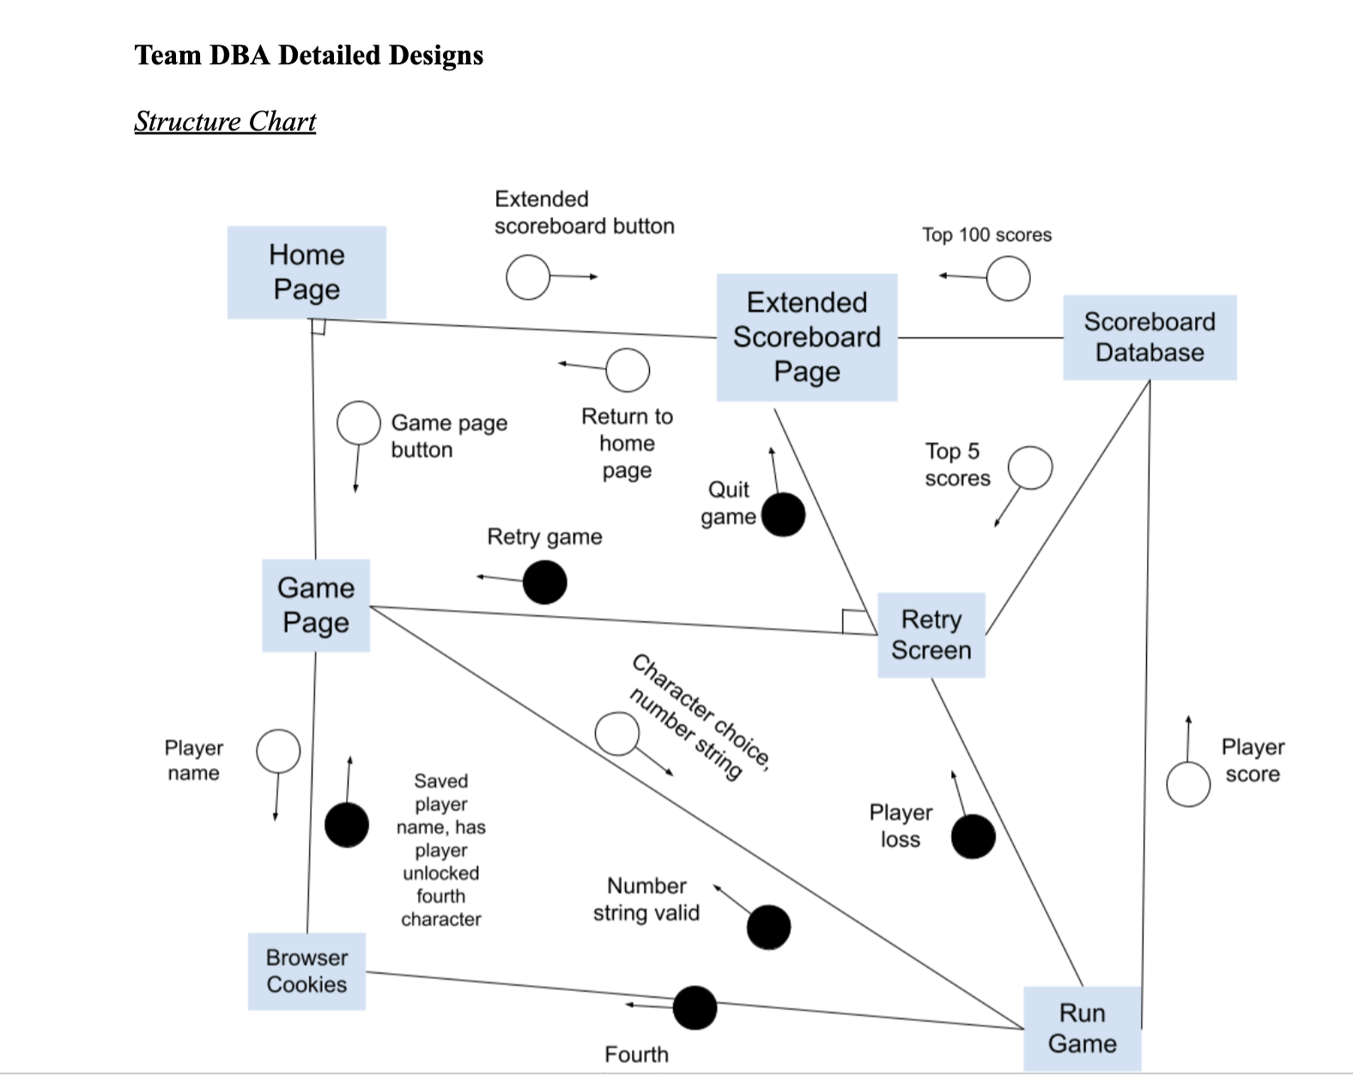
Programmer’s Guide

Project Name: Fraction Runner
Team Name: Team DBA
Team Members:
- Gregory Shelton gpsc7c@umsl.edu
- Maija Garson mmgzzn@umsl.edu
- Kayla Thurman kethurman@mail.umsl.edu
- Sedaf Shakeel ssmkh@missouri.edu
- James Platt jbpkcd@mail.umsl.edu

Revision History:

04/04/2023 – 1st Draft
04/11/2023 – Revision, publish to GitHub
04/12/2023 – Revision per team discussion
04/14/2023 – Revision per team discussion

Section 1: What a Programmer should know about Fraction Runner

Implementing the Fraction Runner game: The game is built using HTML, CSS, and JavaScript. The uses a simple game loop to update the game state and render the graphics.

To maintain the Fraction Runner game, you will need a basic understanding of HTML, CSS, and JavaScript. It is recommended to use an integrated development environment (IDE) to write and test your code.

For purposes of our current endeavor, everything here should already be handled, but note usage in case of errors mysql database has two important user types, "root" (administration, passcode is set as "VfX!565WW!t552") intended to be set with all permissions, and "siteuser" (average access to database, passcode set as "edcvfr43edcvfr4") intended to be set with permissions to DELETE, INSERT. SELECT, and UPDATE records.
Finally, intended servername should be at "127.0.0.1", for testing, Machine Local Network IP (usually 198.68.0.*) Or webserver IP ,subject to change based on webserver settings.

Section 2: High Level Design

Section 3: More Detailed Designs

Pseudocode Detailed Design for Fraction Runner
Front page:
CSS: all centered
<header (Welcoming)>
<close header>
<introduction to concept and game>
<link to video>
<close link>
<close intro>
<images>
<static images>
<close static images>
<gif of game>
<close gif of game>
<close images>
<container>
<button>
<link to game>
<close link>
<close button>
<button>
<link to extended scoreboard>
<close link>
<close button>
<close container>
<footer>
<close footer>
Game page:
CSS: all centered
<header (Welcoming)>
<close header>
<game border>
<game window>
<close window>
<close border>
<container>
<button>
<link to intro>
<close link>
<close button>
<button>
<link to extended scoreboard>
<close link>
<close button>
<close container>
<footer>
<close footer>
Extended Scoreboard Page:
CSS: all centered
<header (Welcoming)>
<close header>
<score border>
<scoreboard table (100 rows linked to database)>
<close table>
<close border>
<container>
<button>
<link to intro>
<close link>
<close button>
<button>
<link to game>
<close link>
<close button>
<close container>
<footer>
<close footer>
JS:
Javascript psuedocode:
Function to layout data(information: table name, rank, name, points)
Variables:
Table name
Table row
Table Divider (Rank)
Table Divider (Name)
Table Divider (points)
Table Divider (Repeating String Generated)
Set dividers = children of row
Set row = child of table
Function to repeat above function 100 times onload (tablename, name, points)
if(i = 0, i< 100, i++){
Function to layout data(tablename, rank(i), name at rank I, points at name at rank i
}
Game:
Game start
Print briefer explanation of math that was referenced on the intro page
Event listener for pressing of mute button
IF audio is NOT muted
mutes audio
ELSE
unmutes audio
Event listener for pressing of quit button
Pauses gameplay
Asks confirmation that player wants to return to home page
IF player clicks YES to return to home page
returns user to intro page
IF player clicks NO to continue game
resume gameplay
Cookie check
IF no cookie
input window for name to put on scoreboard
IF cookie present
checks for unlocked fourth character
Number input window, onhover:
add color around box
onclick: change color around box
Event listener for number input window
IF number input is out of range (<1 or >9)
display some appropriate error messaging
allow user to redo input
IF number is valid
Generate repeating decimal
Count number of significant digits in number
Divide number by equal number of 9s (ex. 221332/999999)
Show brief fake load screen showing the number get generated in a flashy way.
proceed with related game logic
Number input window, onhover:
add color around box
onclick: change color around box
Event listener for character select to choose avatar
Onclick: sets variable that determines character
Sets strings so that character sprites display correct character
Event listener for GAME START button
Onclick:
start game
begin generating ground made of numbers as well as obstacles
Event listener for jump:
IF character is not jumping:
trigger jump
set character state to jumping
when jump action is complete
reset character state
ELSE
do nothing
Event listener for duck:
IF character is not ducking:
trigger duck
set character state to ducking
when player releases duck button
reset character state
Event listener for attack:
IF character is not dodging
trigger attack
set character state to attacking
when attack action is complete
reset character state
ELSE
do nothing
event listener for minute passed:
Check transition number
If transition number > 5
transition back to first background
set transition number back to 1
Trigger transition linked to number
reset minute time for next transition
event listener for obstacle collision with character:
Trigger game over
stop movement on page on collision
set player state to loss
Record score
Checks cookies for high score on browser
display top 5 scoreboard with retry/quit buttons
Event listener for retry button, onclick:
Reset score to zero
Reset other relevant variables (character state, transition number,
timer/elapsed time, repeating decimal, etc) back to initial values
Reopens input window for repeating decimal and character select
Event listener for quit button, onclick:
Take user to extended scoreboard page
Event listener for home button on extended scoreboard page
Return user to homepage
scoreboard databases
XML file including rules of database
CREATE TABLE users (
#Variable/column name/ids and rules
#NOT NULL
'user_id' int(10) UNSIGNED NOT NULL AUTO_INCREMENT,
'user_rank' int(10) UNSIGNED NOT NULL,
'user_name' varchar(50) NOT NULL,
'user_score' bigint(10) UNSIGNED,
'fraction' decimal(13,12) UNSIGNED CHECK(fraction>0) CHECK(fraction<1),
'time_set' TIMESTAMP NOT NULL DEFAULT CURRENT_TIMESTAMP,
PRIMARY KEY (user_id)
) ENGINE=InnoDB AUTO_INCREMENT=1 DEFAULT CHARSET=utf8mb4
COLLATE=utf8mb4_0900_ai_ci;
Stored in above cookie
Accessed by:
Scoreboard page
Game Scoreboard
MYSQLAdmin
Trigger or loop to remove lowest score and lower all scores below an added score

Section 4: Installation Instructions

Fraction Runner game runs in a web browser. The installation instructions are quite straight forward. You will simply open a modern web browser. Google Chrome is recommended.
Please navigate to our site: https://www.fractionrunner.com

Installation for a fresh install: Here are the basic steps to implementing the Fraction Runner game:

- Pull files from GitHub: https://github.com/jamesb77/TEAM-DBA.
- Get a domain name and a web host.
- Recreate the file structure inside codebase/webpages (directory / folders) to the web service provider's standard, They are set up for HostGator's file service, using the public_html directory hostgator provides as a place to import the file structure from codebase/webpages. If another service with different requirements is used, ensure that all file connections (the links in button divs as well as all links and css/js/php class references in the head and above the <!DOCTYPE> are changed to reflect this.
(NOT RECOMMENDED)
- If the user chooses to run tests on their machine, export resulting database using MySQL server 8.0.
Otherwise, fire Database Setup Code from “Database Setup Code.sql” in codebase/database subfolder of webpages. This will create the table that will store the high score, fractions and user information database between game sessions. We choose this method because locally hosting the database off-server is not a valid option in this case, and the numbers and user data need to be stored on separate tables to prevent column bloat. We are using MySQL within php to access the server.
- Change password, hostname and database name listed in the scoreDatabaseFunctions.php file under function()makeConnection to those provided by your webhost, and replace all instances of fractio3_dba with the new database name.
- [IMPORTANT]
Firing query "Database Setup Code" in dba/codebase/database using MySQL Workbench, phpMyAdmin, or similar is REQUIRED to set up a local/serverside database.
- Permissions for a fresh install in the MySQL userbase
- Create a user that has privileges to use all options for queries for use in serverside administration
- Create a user profile that is based off the user listed in the scoreDatabaseFunctions.php file under function()makeConnection. This user should, for safety's sake, be created with only the following 4 permitted actions: INSERT, DELETE, SELECT, and UPDATE.

User can then be brought to our homepage where there are several options including to start the game.

Appendix A: Implementation Code

WEB PAGE

HTML -
<!DOCTYPE html>
<html lang="en">
<head>
<meta charset="UTF-8" />
<meta name="viewport" content="width=device-width, initial-scale=1.0" />
<title>Document</title>
<link rel="stylesheet" href="style.css" />
</head>
<body>
<script src="scripts.js"></script>

<div class="game">
<div id="dino"></div>
<div id="cactus"></div>
</div>
</body>
</html>

CSSS
.game {
width: 600px;
height: 200px;
border: 1px solid black;
margin: auto;
}

#dino {
width: 50px;
height: 50px;
background-image: url(img/trex.png);
background-size: 50px 50px;
position: relative;
top: 150px;

}

.jump {
animation: jump 0.3s linear;
}

@keyframes jump {
0% {
top: 150px;
}

30% {
top: 130px;
}

50% {
top: 80px;
}

80% {
top: 130px;
}
100% {
top: 150px;
}
}

#cactus {
width: 20px;
height: 40px;
position: relative;
top: 110px;
left: 580px;

background-image: url("img/cactus.png");
background-size: 20px 40px;

animation: block 1s infinite linear;
}

@keyframes block {
0% {
left: 580 px;
}

100% {
left: -20px;

}

JavaScript -
Enemy creation:
class Enemy {
constructor(x, y, width, height) {
this.x = x;
this.y = y;
this.width = width;
this.height = height;
this.isAlive = true;
}

draw() {
// Code to draw the enemy on the canvas
}

takeDamage() {
this.isAlive = false;
this.die();
}

die() {
// Code to remove the enemy from the canvas and update the game state
}
}

Character creation:
class Character {
constructor(x, y, width, height, maxHealth) {
this.x = x;
this.y = y;
this.width = width;
this.height = height;
this.isJumping = false;
this.jumpSpeed = 10; // The speed at which the character jumps
this.jumpHeight = 100; // The maximum height of the character's jump
this.jumpDuration = 20; // The number of frames the jump will take
this.jumpFrames = 0; // The number of frames the character has been jumping
this.jumpDirection = 1; // 1 means the character is going up, -1 means the character is going down
this.isDucking = false;
this.health = maxHealth;
}

jump() {
if (!this.isJumping && !this.isDucking && !this.isAttacking) {
this.isJumping = true;
this.jumpFrames = 0;
this.jumpDirection = 1;
}
}

update() {
if (this.isJumping) {
this.jumpFrames++;

// Calculate the character's vertical position based on the current jump frame
const yDelta = this.jumpSpeed * this.jumpDirection;
const newY = this.y - yDelta;

// If the character has reached the maximum jump height, start descending
if (this.jumpFrames >= this.jumpDuration || newY <= this.jumpHeight) {
this.jumpDirection = -1;
}

// If the character has landed, reset the jump state
if (newY >= 200) {
this.isJumping = false;
this.jumpFrames = 0;
this.jumpDirection = 1;
}

// Update the character's position
this.y = newY;
}
}

duck() {
if (!this.isJumping && !this.isDucking && !this.isAttacking) {
this.isDucking = true;
this.height = this.height / 2; // reduce the character's height to make it look like it's ducking
}
}

standUp() {
this.isDucking = false;
this.height = this.height * 2; // restore the character's original height
}

isTouching(obj) {
return (
this.x < obj.x + obj.width &&
this.x + this.width > obj.x &&
this.y < obj.y + obj.height &&
this.y + this.height > obj.y
);
}

attack(enemy) {
if (!this.isJumping && !this.isDucking && !this.isAttacking) {
this.isAttacking = true;
// attack code here, for example:
if (this.isTouching(enemy)) {
enemy.takeDamage();
}

}
}

takeDamage() {
if(this.isTouching(enemy))
this.health -= 10; // Character loses 10 health points when hit by an enemy
if (this.health <= 0) {
this.die();
}
}

die() {
// Code to handle the character's death
}

handleKeyDown(event) {
if (event.code === 'Space') {
this.jump();
} else if (event.code === 'ArrowDown') {
this.duck();
}
}

handleKeyUp(event) {
if (event.code === 'ArrowDown') {
this.standUp();
}
}

// other methods for drawing the character and handling collisions with other objects
}

const character = new Character(100, 200, 50, 100); // example width and height

document.addEventListener('keydown', (event) => {
character.handleKeyDown(event);
});

document.addEventListener('keyup', (event) => {
character.handleKeyUp(event);
});

PHP –
<!DOCTYPE html>
<?php
include './ScoreServerConnect.php';
?>
<html lang="en">
<head>
<meta charset="UTF-8" />
<meta name="viewport" content="width=device-width, initial-scale=1.0" />
<title>Document</title>
<link rel="stylesheet" href="style.css" />
</head>
<body>
<script src="scripts.js"></script>

<div class="game">
<div id="dino"></div>
<div id="cactus"></div>
</div>
<div>
<a href="../Homepage/GroupIntroPage.php"><button>Front Page</button></a>
</div>
<div>
<a href="../Scorepage/ScorePage.php"><button>Extended Scoreboard</button></a>
</div>
<?php /*
#This is test code for later insertion of data
$username = 'test';
$password = 'password';
#this line creates the instruction to be sent
$sql = "INSERT INTO scoreboard_dba.users VALUES (0,2,$username,$password,2,'001001001');";
#This line sends the instruction, success line can be changed, and sends the error otherwise
if ($dbconn->query($sql) === TRUE) {
echo "New user entry created successfully";
} else {
echo "Error: " . $sql . "<br>" . $dbconn->error;
}
#This id is a line that pulls information
$sql = "SELECT * FROM scoreboard_dba.users"
$dbconn->close();*/
?>
<?php
#SET @r=0;
#UPDATE table SET Ranking= @r:= (@r+1) ORDER BY Score DESC;
?>
</body>
</html>

DATABASE

Database Setup:
#initial creation of database, drop is delete in this case, use states we're using it as the base database going forwards
DROP DATABASE IF EXISTS `scoreboard_dba`;
CREATE DATABASE `scoreboard_dba`;
USE `scoreboard_dba`;

#character sets
SET NAMES utf8mb4 ;
SET character_set_client = utf8mb4 ;

#creation of an actual table within the database, users is the database name
CREATE TABLE `users` (
#Variable/column name/ids and rules
#NOT NULL
`user_id` int NOT NULL AUTO_INCREMENT,
`user_name` varchar(50) NOT NULL,
`user_score` bigint,
`password` varchar(50) NOT NULL,
`digits` varchar(9),
#`time_set` TIMESTAMP NOT NULL DEFAULT CURRENT_TIMESTAMP,
PRIMARY KEY (`user_id`)
) ENGINE=InnoDB AUTO_INCREMENT=1 DEFAULT CHARSET=utf8mb4 COLLATE=utf8mb4_0900_ai_ci;

CREATE TABLE `fractions` (
#Variable/column name/ids and rules
#NOT NULL
`digits` varchar(9),
`fraction` decimal(10,9) CHECK(fraction>0) CHECK(fraction<1),
`divisor` int,
PRIMARY KEY (`digits`)
) ENGINE=InnoDB AUTO_INCREMENT=1 DEFAULT CHARSET=utf8mb4 COLLATE=utf8mb4_0900_ai_ci;

Database Trigger Code:
SELECT * FROM scoreboard_dba.users;

DELIMITER $$

CREATE TRIGGER trigger1
BEFORE INSERT
ON users
FOR EACH ROW
BEGIN
SELECT COUNT(*) INTO @count FROM users;
IF @count >= 10000 THEN
DELETE FROM users
WHERE user_rank = (SELECT min(user_rank) FROM users);
END IF;
END
$$

DELIMITER ;

Appendix B: User Manual

User Manual

Welcome to Fraction Runner, an educational running game!

In this game, the object is to see how long you can stay alive.
Upon start, the player is asked to write a number.
The game puts player’s number in a fraction as the numerator over the same number of 9s in denominator.
(Example: 443 becomes 443/999)
The division produces a string of repeating decimals which will be displayed as the ground.
(From our earlier example: 443/999 becomes 0.443443443...)
The player runs on top of the numbers using Jump, Duck, or Attack to stay alive.
The player that stays alive the longest time is the winner.
When running, check out the repeating decimals.

On the Home Screen you will see three choices:
Fraction Runner – select when you are ready to begin the game
Introduction Page – click to learn more about the game and its developers
Top 100 Scoreboard – pick this to see who has the high score

Controls:
Each character can perform three different actions:
*Jump – spacebar or click jump
*Attack – enter or click attack
*Duck – down or click duck

Gameplay:
At the start, the player is asked to select a character.
There is no skill difference between the characters.
When starting the game, the player must pick a number up to 999,999,999.
After entering the number, the running game begins.

The object of the game is to see how long the player can stay alive.
The timer starts at the beginning of the game.
Once the player has been hit by an object, the game is over.
The time is calculated and added to the Scoreboard.

Tips and Tricks:
*There are three different obstacles. Each one can only be defeated by the correct action.
*Use Jump when a hole appears
*Use Duck when a bat is flying
*Use Attack to break a wall
*The runner will speed up as time continues. Stay alert!

We Thank you for playing Fraction Runner.

Appendix C: Test Plan

Our test plan involves testing for the following:
*MySQL database – make sure insert, delete, update actions work from login and gamepage. Make sure Select actions work from score page and the gamepage.
*JavaScript – make sure character actions match the buttons.
*CSS – make sure the site loads correctly from the intro page. Check the loading, colors, size, etc, of the game during each step of input. Check scoreboard loads properly.
*HTML – make sure site loads and structure is intact.

* Fraction Runner is still in development. This Programmer’s Guide will be updated accordingly.

